1. Tampilkan data Name, Region, Population pada tabel Country dan Language berdasarkan Country Population diatas rata-rata.

[SELECT](http://localhost/phpmyadmin/url.php?url=https://dev.mysql.com/doc/refman/8.0/en/select.html) country.Name, country.region, country.Population, countrylanguage.Language FROM `country` INNER JOIN countrylanguage ON country.Code=countrylanguage.CountryCode WHERE Population > ([SELECT](http://localhost/phpmyadmin/url.php?url=https://dev.mysql.com/doc/refman/8.0/en/select.html) [AVG](http://localhost/phpmyadmin/url.php?url=https://dev.mysql.com/doc/refman/8.0/en/group-by-functions.html#function_avg)(Population) FROM country); 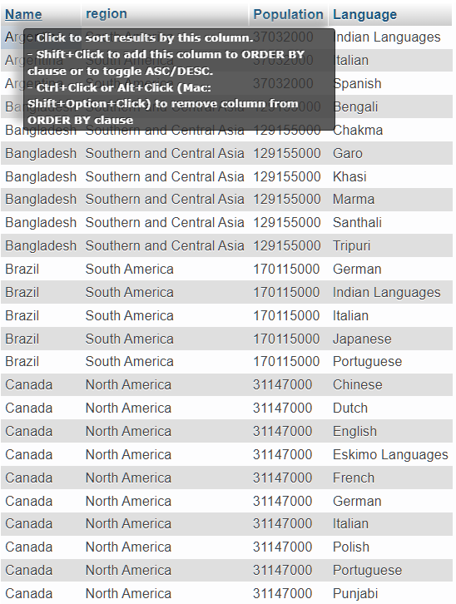

1. Tampilkan data Name, District, Population pada tabel City dan Name Country berdasarkan City Population diatas rata-rata [SELECT](http://localhost/phpmyadmin/url.php?url=https://dev.mysql.com/doc/refman/8.0/en/select.html) city.Name, city.District, country.Name, city.Population FROM `city` INNER JOIN country ON city.CountryCode=country.Code WHERE city.Population > ([SELECT](http://localhost/phpmyadmin/url.php?url=https://dev.mysql.com/doc/refman/8.0/en/select.html) [AVG](http://localhost/phpmyadmin/url.php?url=https://dev.mysql.com/doc/refman/8.0/en/group-by-functions.html#function_avg)(city.Population) FROM city); 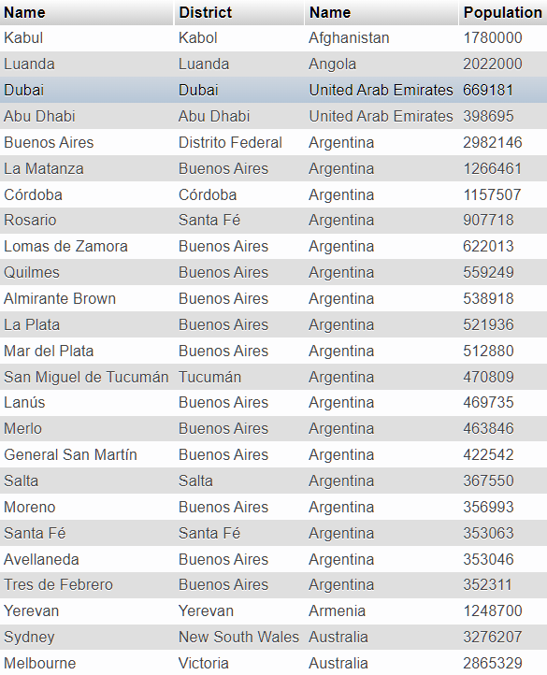
2. Tampilan data Name, Region, Population pada tabel Country berdasarkan IndepYear null [SELECT](http://localhost/phpmyadmin/url.php?url=https://dev.mysql.com/doc/refman/8.0/en/select.html) country.Name, country.region, country.Population FROM `country` WHERE country.IndepYear [IS](http://localhost/phpmyadmin/url.php?url=https://dev.mysql.com/doc/refman/8.0/en/comparison-operators.html#operator_is) NULL; 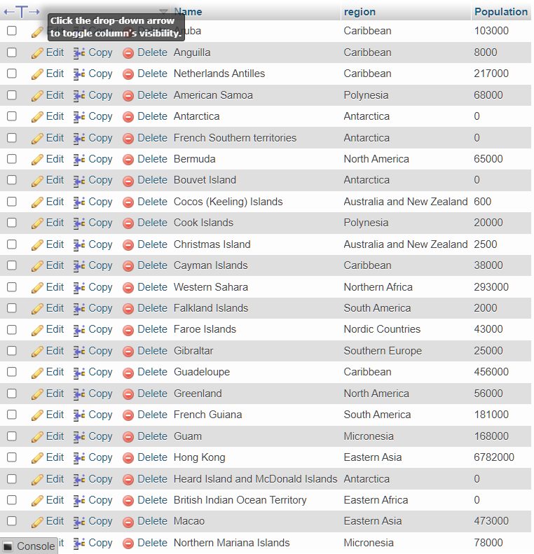
3. Tampilkan data jumlah Country berdasarkan Region yang memiliki Jumlah Country diatas 5

[SELECT](http://localhost/phpmyadmin/url.php?url=https://dev.mysql.com/doc/refman/8.0/en/select.html) country.Name, [COUNT](http://localhost/phpmyadmin/url.php?url=https://dev.mysql.com/doc/refman/8.0/en/group-by-functions.html#function_count)(country.Name) AS 'Jumlah Country diatas 5' FROM country GROUP BY country.Region HAVING [COUNT](http://localhost/phpmyadmin/url.php?url=https://dev.mysql.com/doc/refman/8.0/en/group-by-functions.html#function_count)(country.Name) > 5;

